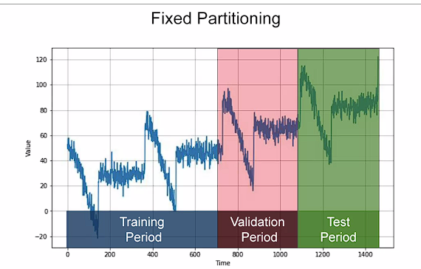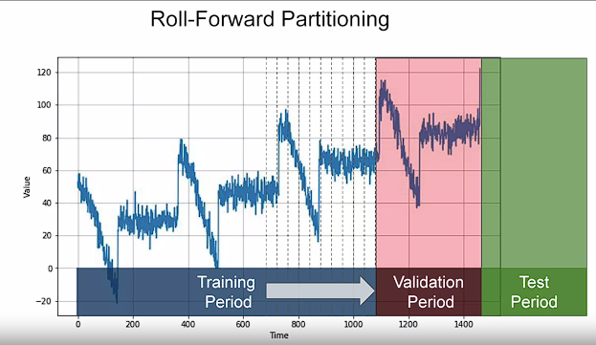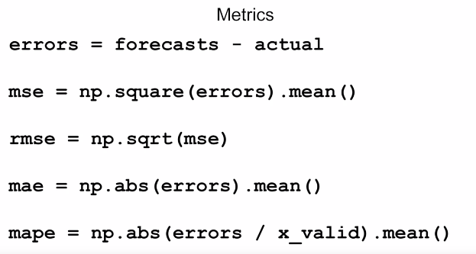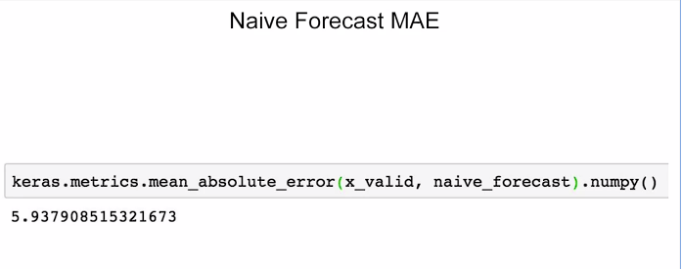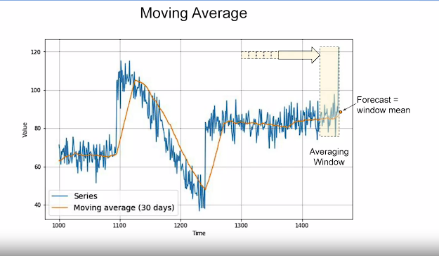

One method to avoid this is to remove the trend and seasonality from the time series with a technique called differencing

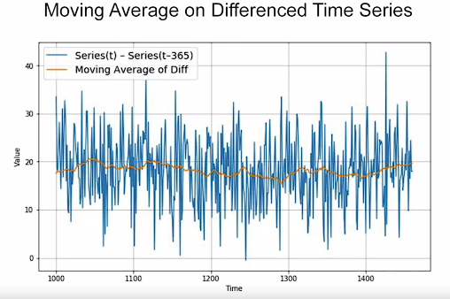

. We can then use a moving average to forecast this time series which gives us these forecasts. But these are just forecasts for the difference time series, not the original time series. If we measure the mean absolute error on the validation period, we get about 5.8. So it's slightly better than naive forecasting but not tremendously better. You may have noticed that our moving average removed a lot of noise but our final forecasts are still pretty noisy. Where does that noise come from? Well, that's coming from the past values that we added back into our forecasts. So we can improve these forecasts by also removing the past noise using a moving average on that

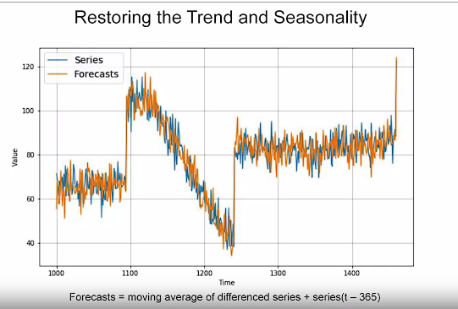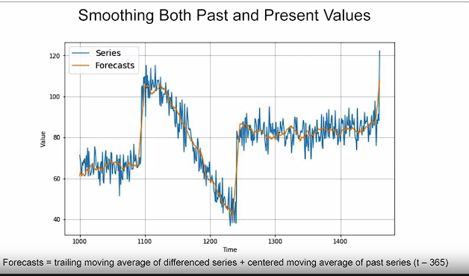

Trailing versus centered windows

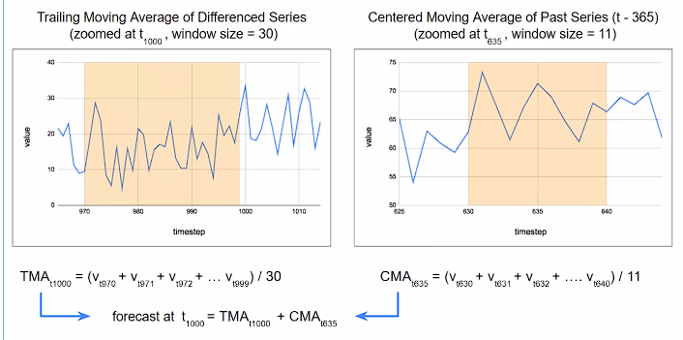

Moving averages using centered windows can be more accurate than using trailing windows. But we can't use centered windows to smooth present values since we don't know future values

# Preparing features and labels

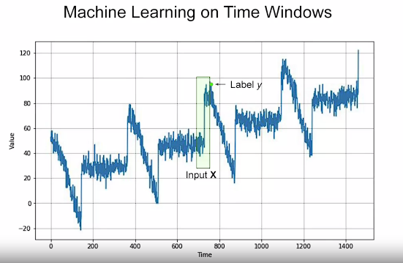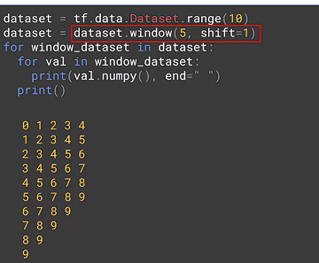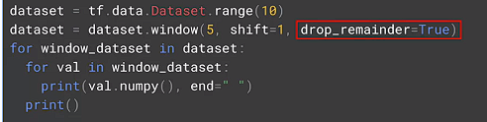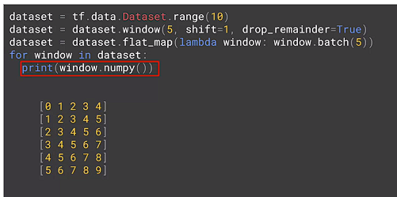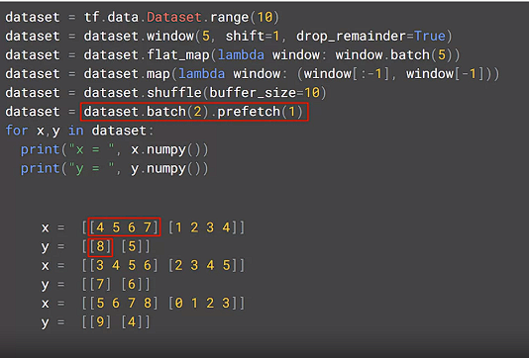

# Feeding windowed dataset into neural network

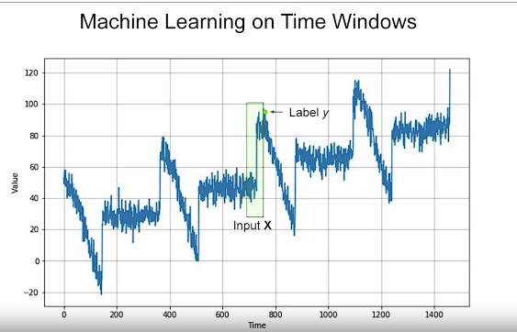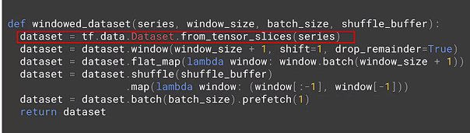

# Conceptual overview

A Recurrent Neural Network, or RNN is a neural network that contains recurrent layers. These are designed to sequentially processes sequence of inputs. RNNs are pretty flexible, able to process all kinds of sequences. As you saw in the previous course, they could've been used for predicting text. Here we'll use them to process the time series.

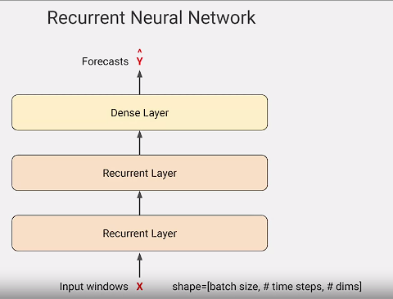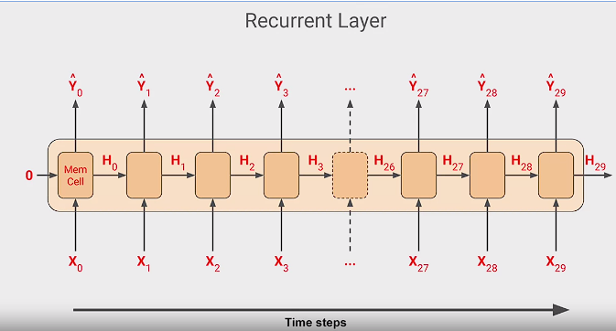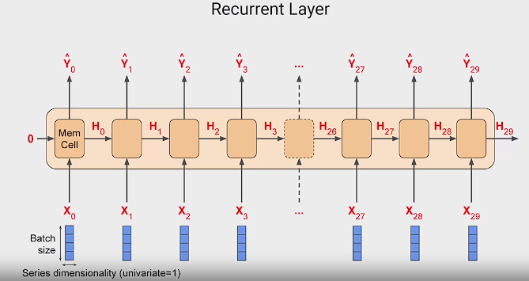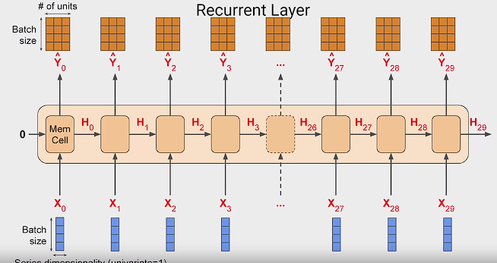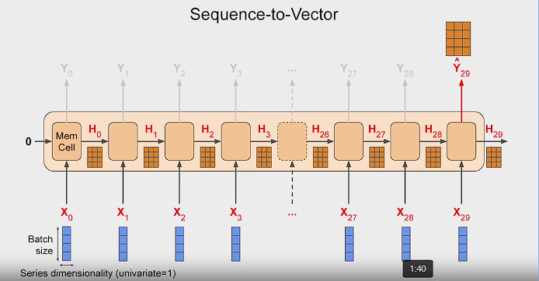

# Outputting a sequence

# Adjusting the learning rate dynamically

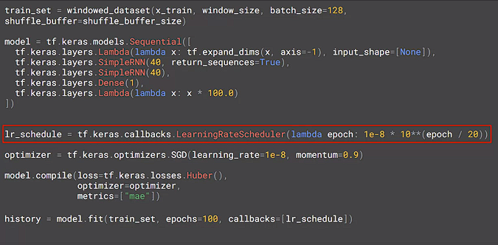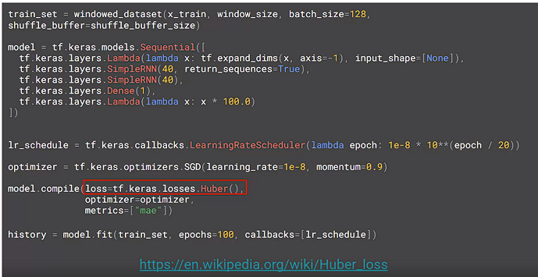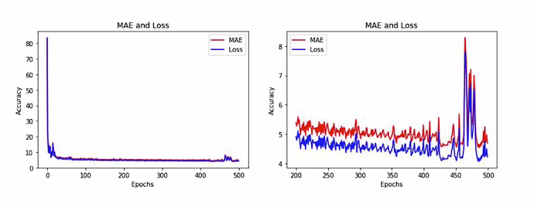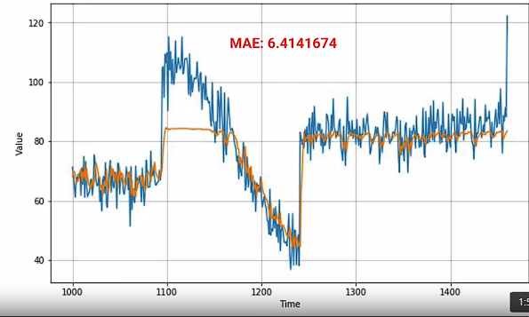

# LSTM

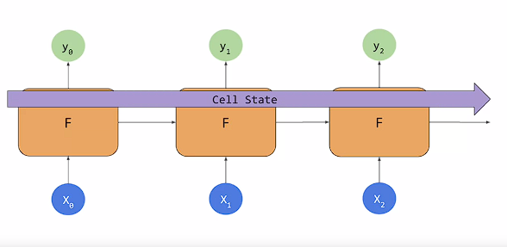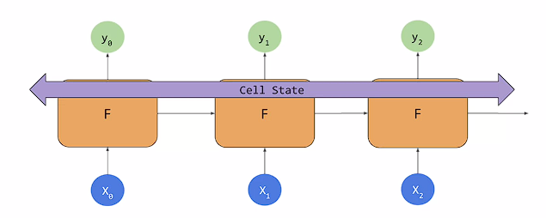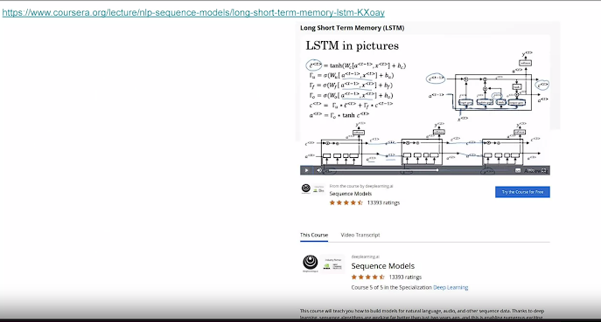

# Coding LSTMs

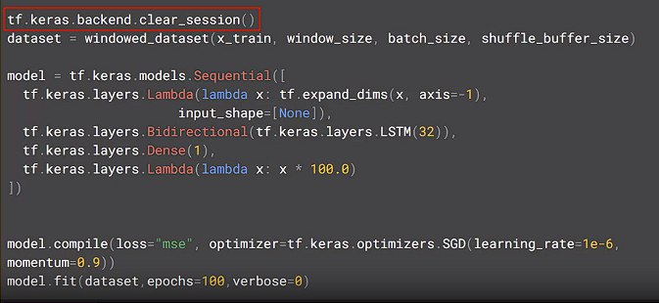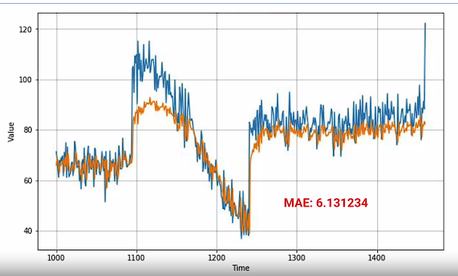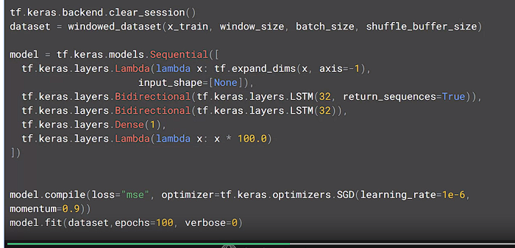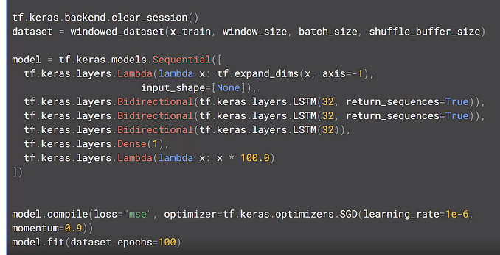

# Convolutions

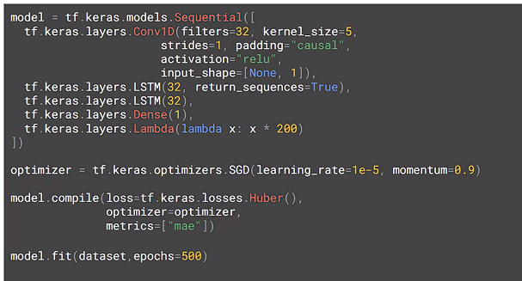

# Bi-directional LSTMs

